William M Duggan

IS601 – Project 3 submission

Github link: <https://github.com/wmduggan41/IS601-Project-3.git>

Postman images to show all players: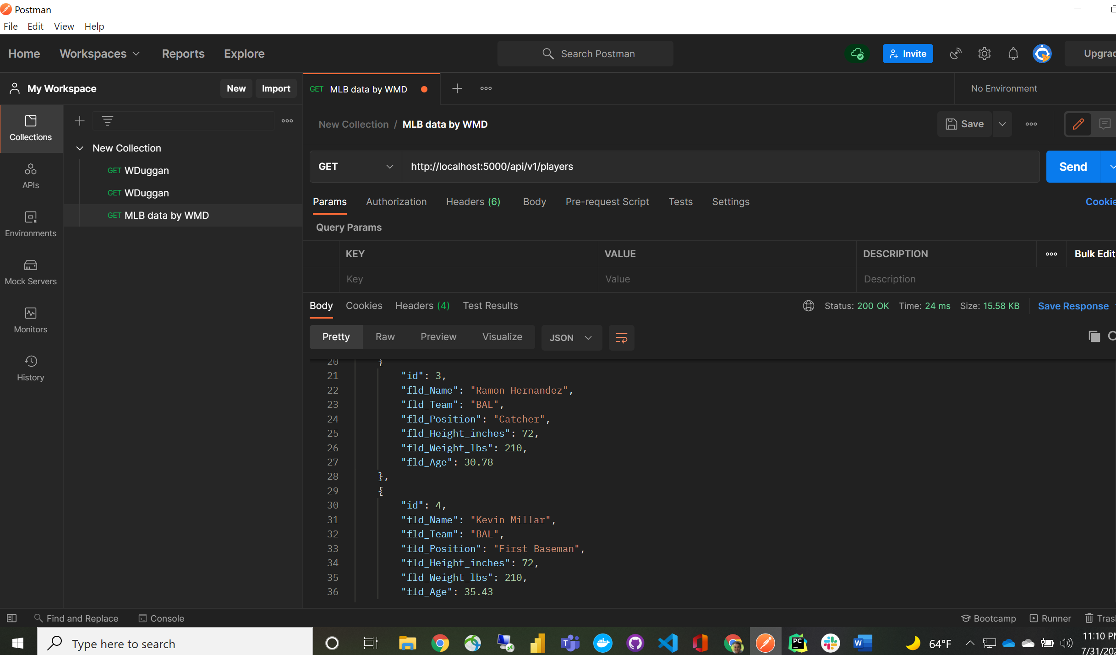

Postman to show single player by ID:

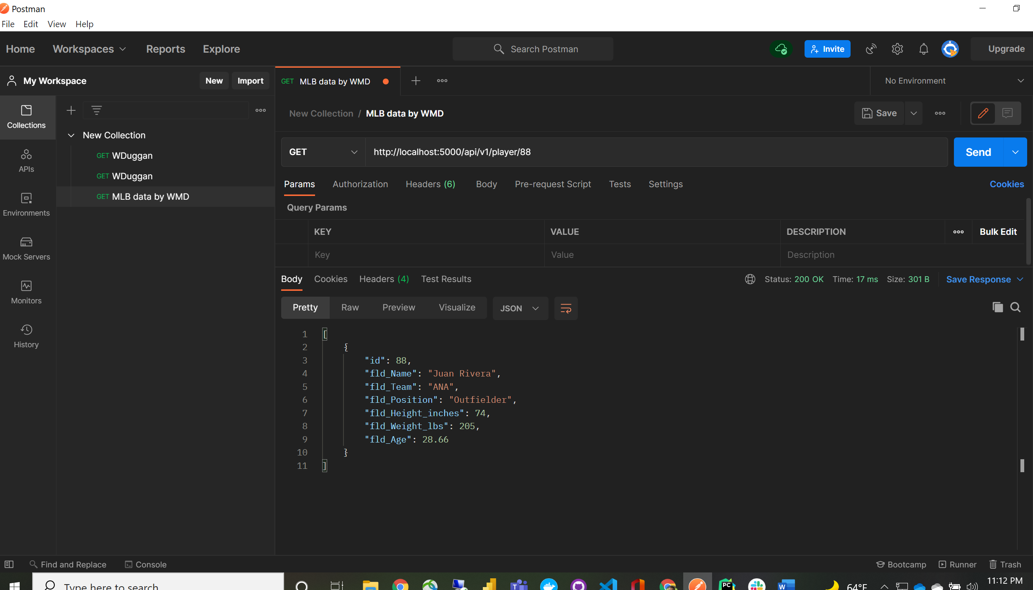

Postman to add new player:

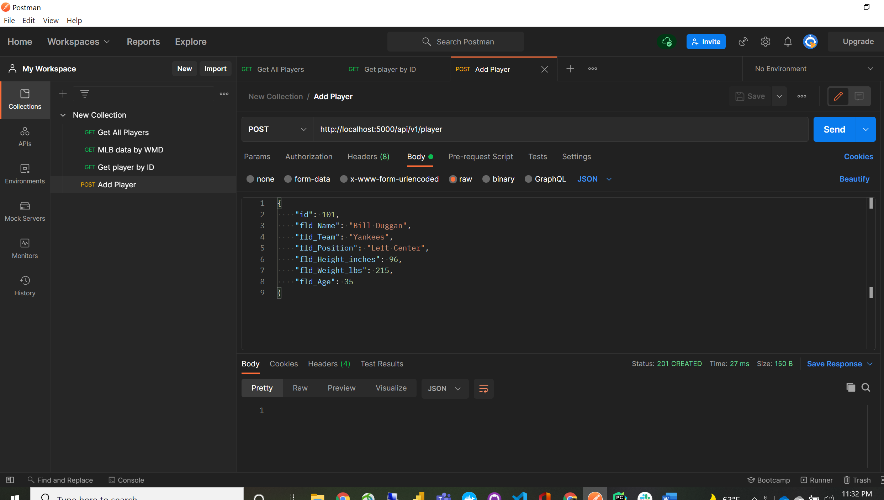

Postman to render and show change:

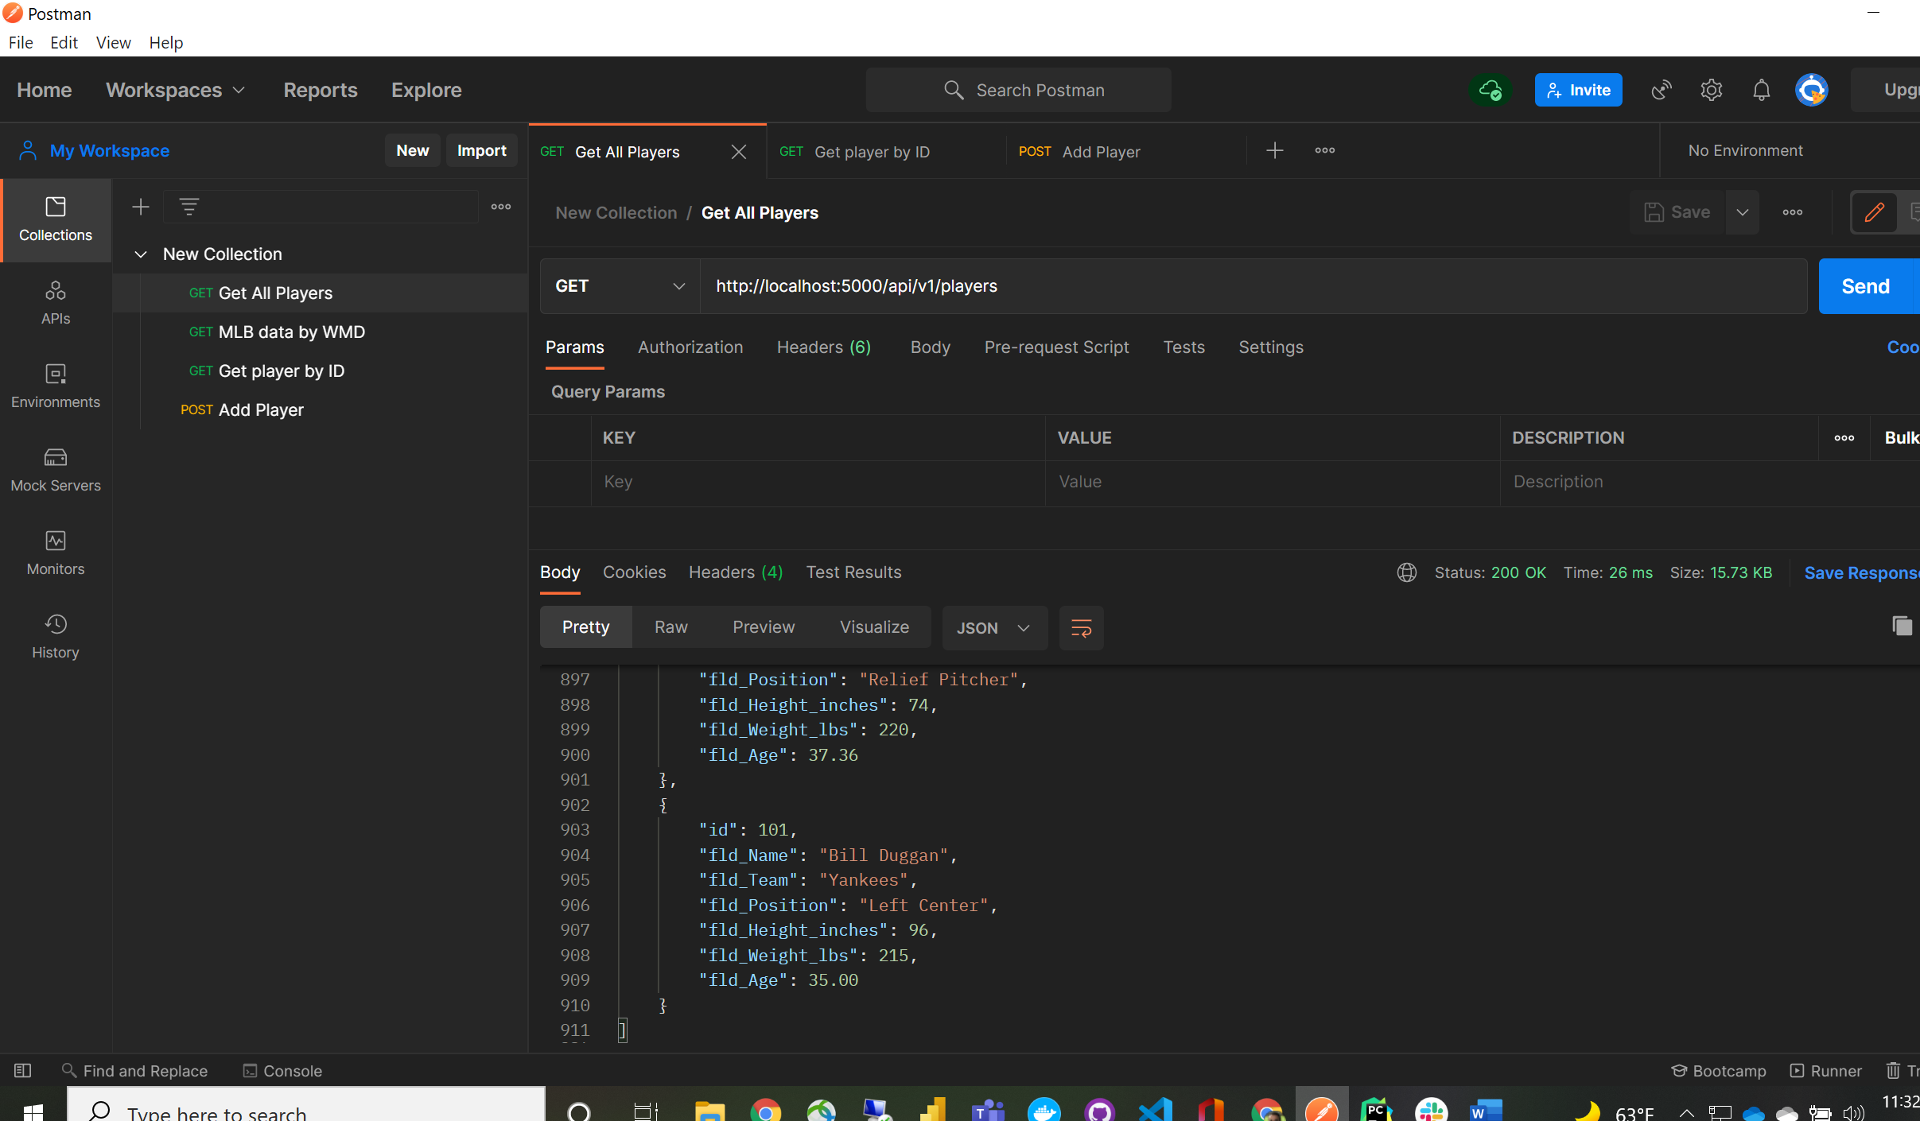

Postman to update existing player details, im not that tall:

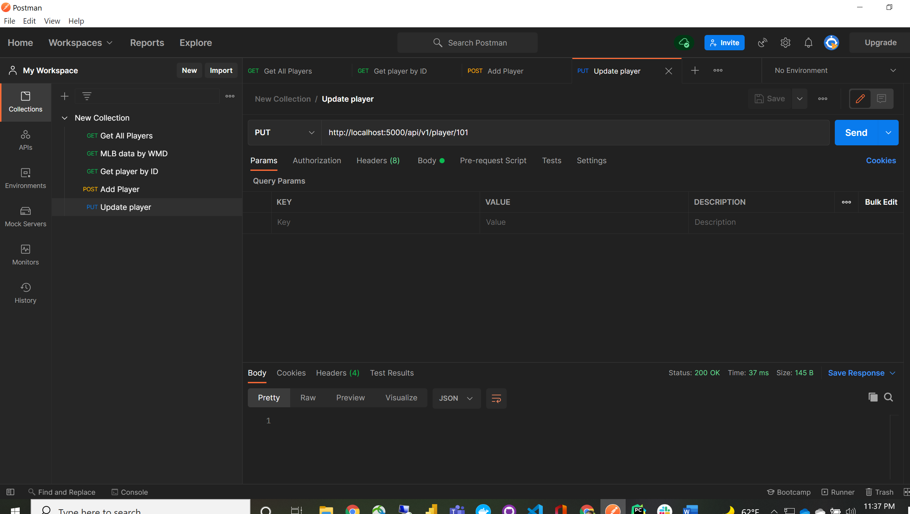

Postman to render my changes and reflect:

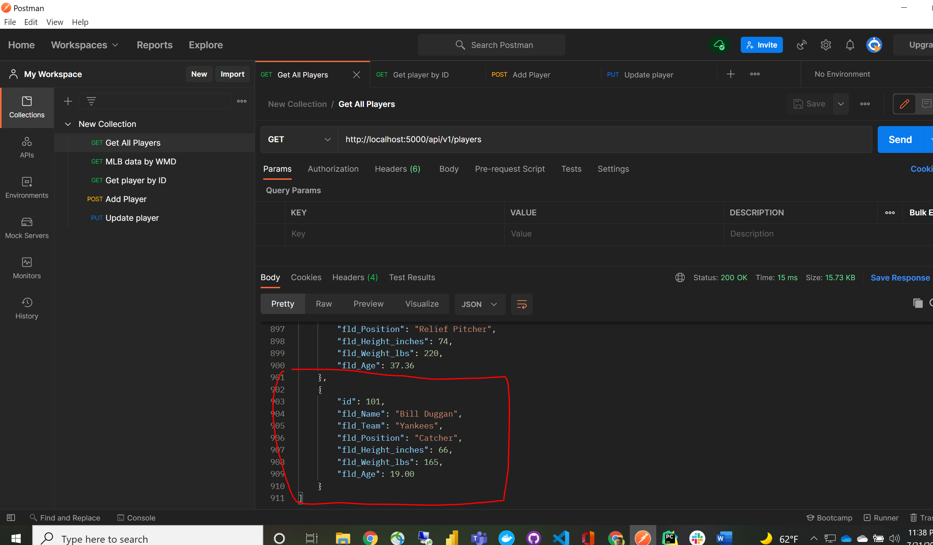

Postman to delete player by ID:

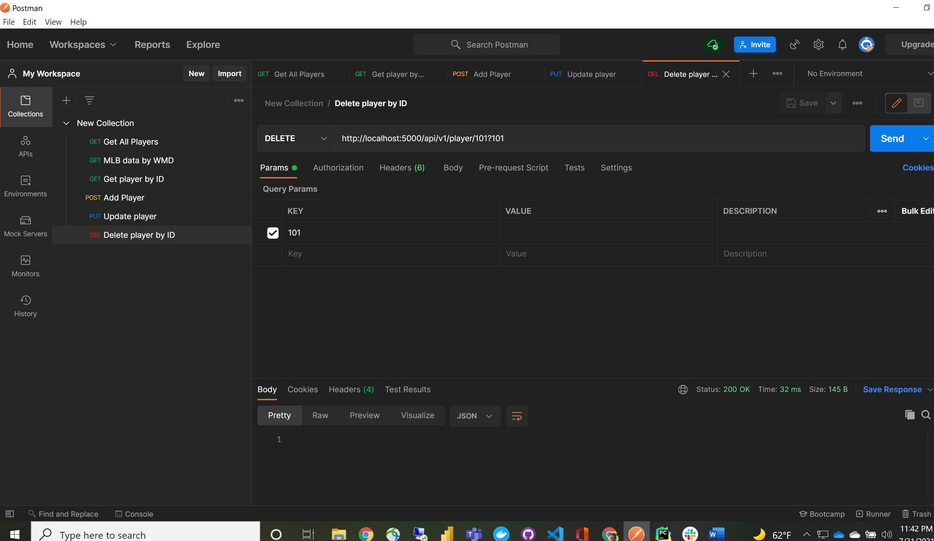

Postman to render changes and remove me from baseball ☹:

